**Experiment No 10:**

creation and traversing a linked list

**Aim:** A program for creating and traversing a linked list.

**Theory:**

**Linked List:**

A link list or a one-way link list, is a linear collection of data elements, called nodes, where the linear order is given by means of pointers.

Each node is divided into two parts:

1) First part contains the information of the elements (eg. Name, address)

2) The right part represents the next pointer field of the node, and there is arrow drawn from it to the next node in the list

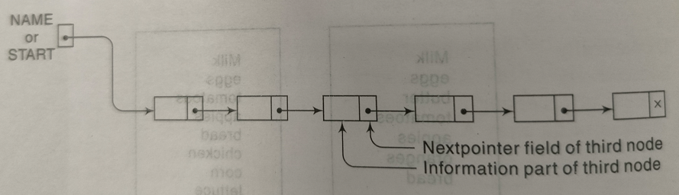

Linked list with 6 nodes

**Traversing a linked LIST**

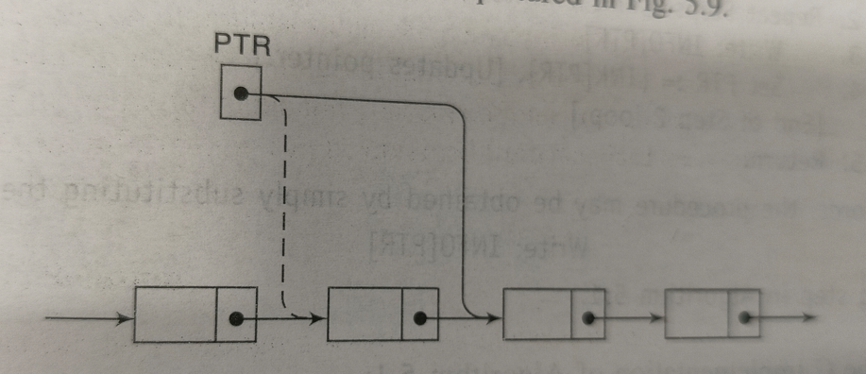

PTR:=LINK[PTR]

Node that is currently being processes. Since LINK[PTR] points to the next node to be processed. Thus the assignment moves the pointer to the next node in the list.

**Algorithm to traverse a linked list:**

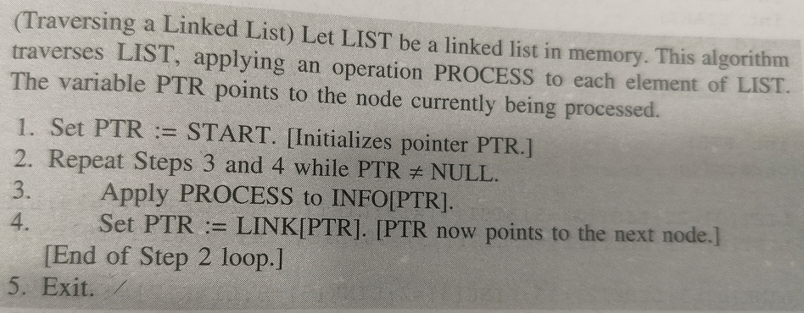

**PROGRAM: [Write program to create and traverse a linked list]**

**OUTPUT:**

**CONCLUSION:**